Due DAte Tuesday, December 6th

KHurram FArooq C16364286

DT211/1 Build A PC Final Report

2016

Table of Contents

Bibliography (references IEEE or Harvard notation) 2

Section 1 Introduction 3

Section 2 Description 5

Section 3 Assembly 9

Section 4 Operating Systems 11

Appendix A Bill of Materials 13

Appendix B Energy Consumption of a PC 15

Appendix C Electrostatic Charge (ESD) 17

Appendix D Sketch of a PC Layout 18

**Bibliography (references IEEE or Harvard notation)**

***Section 1 Introduction***

* Short history of computing

*http://clas.mq.edu.au/speech/synthesis/history_computers/*

* Diagrams of A PC

*Taken from the 2015 Notes in rar zipped PowerPoint form on Build A PC Web courses.*

***Section 2 Description***

* Parts of a computer

*http://www.gcflearnfree.org/computerbasics/inside-a-computer/1/*

*http://www.nmbtc.com/fans/computer-cooling-fans/*

*http://www.computerhope.com/jargon/c/cdrom.htm*

*https://en.wikipedia.org/wiki/Liquid-crystal_display*

***Section 4 Operating Systems***

* Linux commands

*The lab work we got from Jane in the Introduction To OS module.*

***Appendix A Bill Of Materials***

* Gaming computer

*http://www.xoticpc.com/recon-intel-x99-wellsburg-p-6618-1.html*

***Appendix B Power Consumption Of A PC***

* Server farm

*https://www.cloudyn.com/blog/10-facts-didnt-know-server-farms/*

***Appendix C Electrostatic Discharge***

*I watched this video which explained ESD in a simple and precise manner.*

*https://www.youtube.com/watch?v=bxugZ4cyf3Q*

***Sections 1-4***

**Section 1 Introduction**

***About Document***

This document is about all my work I have done to date in this core module called Build a PC. It has information from my very first lab to my very last as well as content from what I learnt in all the lectures from my first semester in year one.

The layout of this document is straight forward, section one as you can see is my introduction. In Section Two, this report will discuss the main parts of a PC such as the microprocessor, hard disk & CD rom etc. and how they interact with each other, how they function and their role in running a PC. In Section Three, it moves onto how a PC should be built and report on how to do it properly from my own personal experience of building a PC in my labs. Then this report will discuss the tools to use and how to use them safely as well as the construction steps involved to build the actual PC. Section Four then brings us to Operating Systems and here it discusses how to install Windows 7 and Ubuntu Linux in dual boot mode. Not just this but this report also includes several Unix commands and how they are used and what they do?

Then after these four detailed sections this report moves onto Appendixes A, B, C and D. Appendix A is a Bill of Materials for a PC. In this it looks at a certain type of a PC and discusses each part of it. The price of each part as well as useful information about each part such as its function and its performance abilities. Moving onto Appendix B, in this report results are used from a Watt Meter test to calculate the power consumptions of a standard PC at home and in a server farm. It gives an example of a well-known server farm and compare its power consumption to everyday PCs. In Appendix C, this report discusses Electrostatic Discharge or ESD and its relevance to PC construction in the lab. Then finally Appendix D includes a sketch of a PCs layout from the very first lab which we used as a reference to construct our own PC.

***Short History of Computing***

The generation of computers is one of the most interesting time periods. Computers have come so far over this period and are now used throughout the world by billions of people.

The First Generation of computers was all about the introduction of vacuum tubes (in the 1950s), these were used internally and the sizes of these were between five and ten centimetres. A vacuum tube is a glass tube which has its gas removed which were used in computers at the time as an amplifier.

Following on from the First Generation, the Second Generation was about transistors (late 50s - mid 60s). These were used for the same reason as vacuum tubes but they were just smaller in size. They were also more reliable than vacuum tubes and because of their size, computers that were built could be built smaller. The Second Generation was big because of the development of computer languages. Programmers could now specify instructions in words using Assembler Languages and Symbolic Languages. These words were then translated into machine code/binary (0s and 1s).

In the mid-60s the Third Generation introduced the integrated circuit, this was a complete circuit of hundreds of components were fitted onto a very small chip which measured less than 5mm. Computers with these circuits were now able to replace computers that used transistors and or vacuum tubes. Again, which made the computer smaller again and demand started to rise for these all-powerful machines.

The Fourth Generation started in the early 70s, large scale integration was achieved where the equivalent of thousands of integrated chips was fitted onto one chip. This increased computer reliability and speed. The first complete general purpose microprocessor became available on a single chip. With the help of very large scale integration the first ever microcomputer was built.

Finally, the Fifth Generation of computers was defined by the Japanese government in the 80s and they set out a plan to create artificial intelligence. Their aim was to make machines that would can perform human tasks, something like the terminator. This has not reached a promising level yet but there has been significant progress in this field.

***Diagrams Of PC***

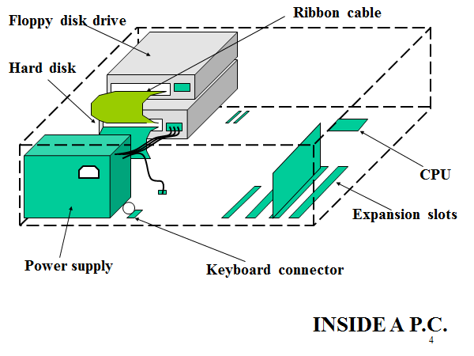

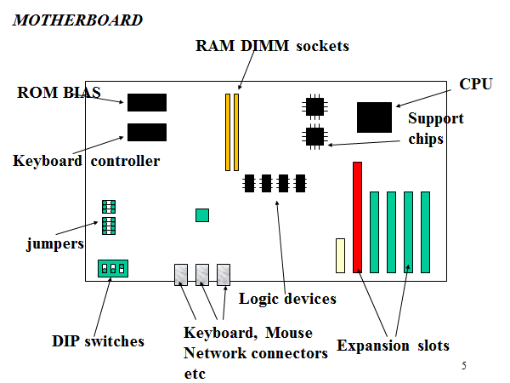

**Section 2 Description**

This section describes the main parts of the computer, the role they play in the running of a PC, how they function and how they interact with the rest of the PC.

***Main Parts of A Computer***

The ***Monitor***, works with a video card inside the computer case which displays text and images on the screen.

A ***Liquid Crystal Display (LCD)*** may be used in monitors, it is a flat panel display that uses modulating properties of liquid crystals. These liquid crystals do not emit light directly. The images are made up of a very large number pixels which display the images onto a screen.

The ***Keyboard*** is used to communicate with the computer, it’s in input device which allows you to enter data into a computer.

The ***Mouse*** is used to navigate what you see on the monitor and allows you to select different options displayed on the monitor.

***Computer Case***, this is the big metal box that holds together all the main and valuable parts of the computer such as the CPU, the motherboard, power supply, disk drives, hard drive etc.….

**Inside** the ***Computer Case*** we have the following components….

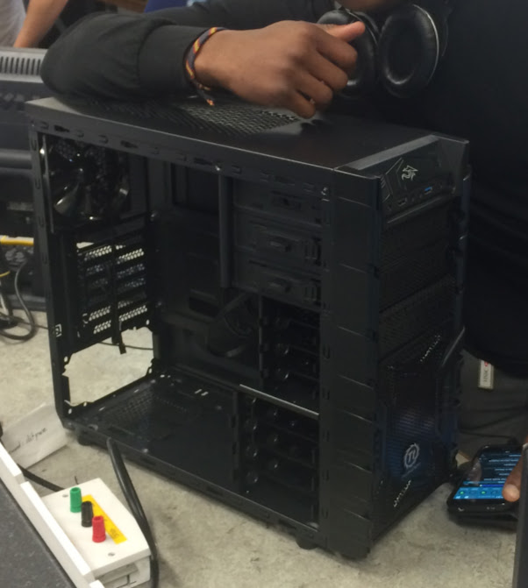

A ***CD ROM (Compact Disk Read Only Memory)*** is used to store computer data in different forms so that they can be used by the computer to be displayed or played. A CD is put into this CD ROM and its data is read. There are different standard transfer rates and access times for CD ROM Drives. For example, a drive speed of single speed has a transfer rate of 1.2 megabits per second and an access time of four hundred seconds.

Then there is the ***Power Supply Unit*** which is self-explanatory. It sends power from the wall socket when it is connected to the different parts of the computer.

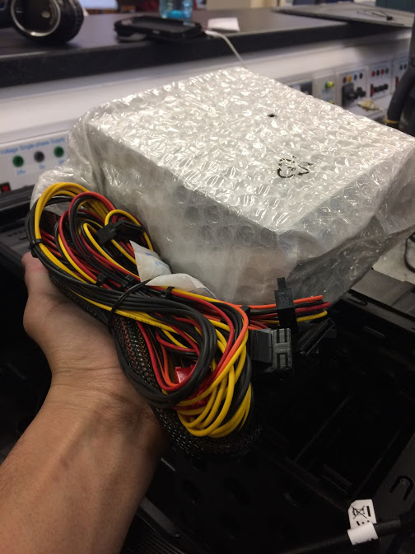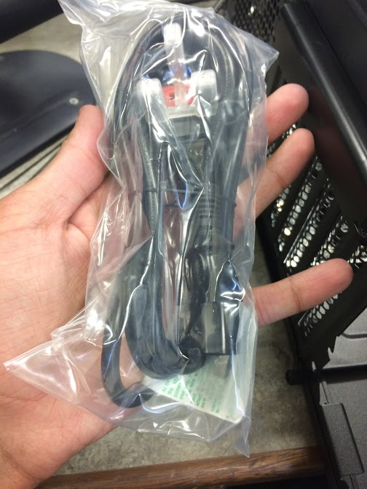

The ***RAM (Random Access Memory)*** is a computer short term memory meaning that data is stored here for a short period before it is replaced or used. When using your computer, everything needs to be saved before you shut down or else you will lose it as it was stored in the RAM or short term memory.

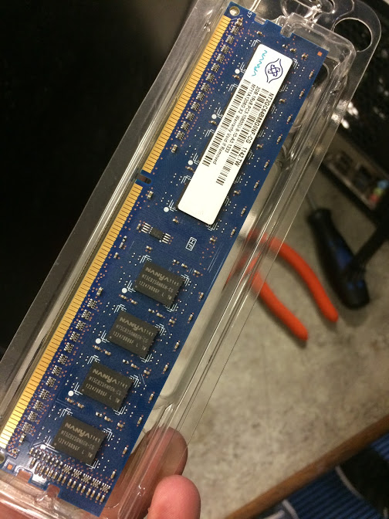

The ***CPU/Microprocessor***, it carries out all sorts of commands and controls the computer. Everything you do is going through this processor and being directed. The speed of this processor determines the speed of a computer, for example an intel core i7 processor is much faster than an i3 processor. A processor speed is measured in megahertz (MHz).

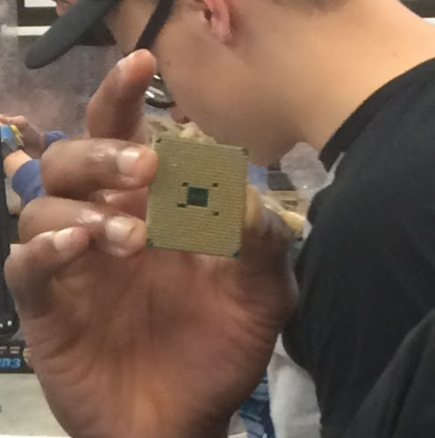

A ***Cooling Fan*** is used to prevent overheating of the CPU, is brings cool air into the computer and takes out warm air. This helps the computer run smoothly for a longer period. Without it the parts of the PC will overheat and get damaged and stop working. The different have electricity running through them constantly and they are delicate. The CPU can 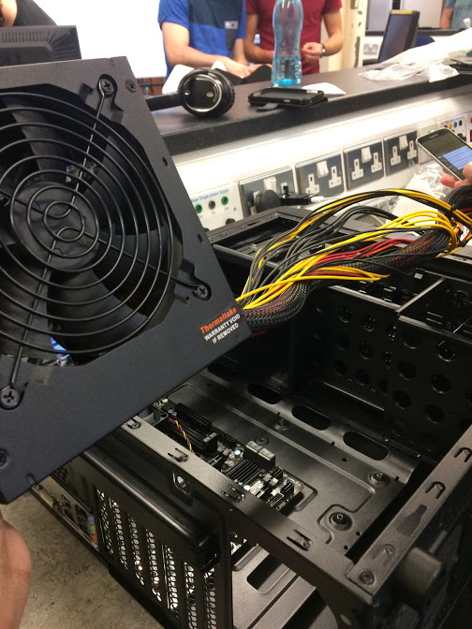melt if it gets too warm.

The ***Hard Drive*** is where everything you have on your PC is stored. It is kind of the opposite of RAM meaning it is also a computer’s long term memory. If you are working on a already saved document, the hard drive will move it to the computer’s short term memory aka the RAM and once this document is edited and saved the hard drive will store it again to keep it safe. In these situations, the RAM and hard drive work hand in hand. Then there is a ***Hard Disk*** which is a storage device, it is a magnetic material coated disk (Platter). A hard drive is a device for storing data into a hard disk. As a Hard Disk and its respective Hard Drive comes in fixed together in a single casing it is called a Hard Disk Drive altogether.

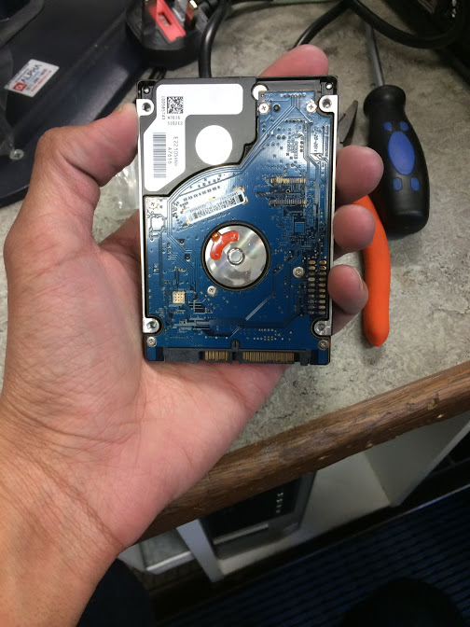

The ***Motherboard***, which is a computer main circuit board. It is the most complicated part of the computer. This connects every part of the computer together. It holds the video card, central processing unit, memory, connectors for the different drives and connections to the computer’s ports such as the USB port.

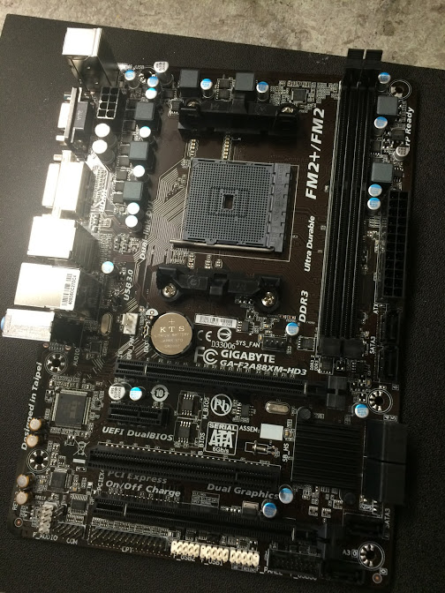

Then comes the different cards in a computer, the ***Sound Card***, ***Network Card*** and ***Video Card***. The ***Sound Card*** controls the sound and allows it to be outputted. These are used for better sound quality and can be bought separately. The ***Network Card*** enables the computer to connect to the internet. Finally, the ***Video Card*** is used to display picture onto the screen.

**Section 3 Assembly**

This section describes how each part of a computer should be installed properly.

***Tools Needed***

1. Screwdrivers
2. Cable ties
3. Anti-static wrist strap
4. Small container
5. Needle nosed pillars
6. Phone flashlight

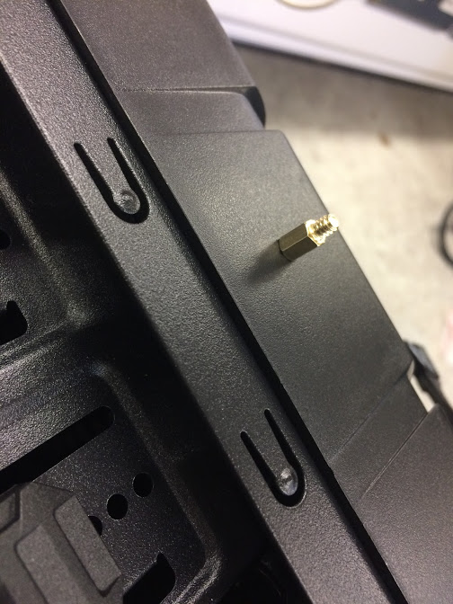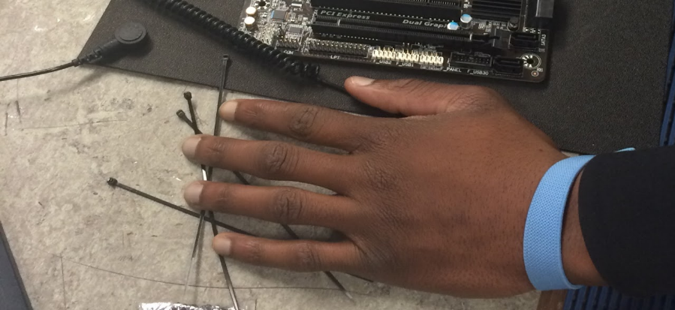

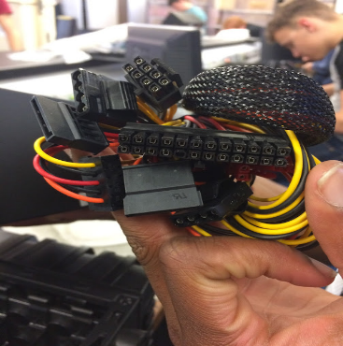

These are the tools that would be needed and will be very useful when building the PC. Screwdrivers for screwing screws to hold together the motherboard and the computer case. Cable ties would be useful for holding the cables inside the computer together neatly so as not to be damaged and found easily. Anti-static wrist strap to avoid electrical shocks when touching metal components of the PC. A small container to keep screws safe. Canned air would be used to clear out any dust from the PC parts and needle noses pillars to carefully but firmly take out screws.

***Parts of PC To be Installed***

1. Processor (CPU)
2. Memory (RAM)
3. Power Supply
4. Motherboard
5. Processor Fan
6. Case Fan
7. Hard Drive

***Order of Construction Steps***

1. Unscrew side panels of computer case and place carefully away from work area.
2. Put on anti-static wrist strap, this will prevent any build-up of static electricity on your body from damaging the components.
3. Next step is to install the motherboard carefully but first install the input-output bezel on the inside and back of the computer. It pushes in from the inside.
4. Install standoffs in the case, these screws into the motherboard. Ensure to check the screw hole locations on the motherboard for exact placement.
5. Lower the motherboard into the case and make sure it aligns with the input-output bezel. Install the screws into the motherboard.
6. Install the hard drive into a bay usually located at the front of the case. Unclip top of bay and put hard drive in and slide back into the bay.
7. Next step is to install the optical drive into the case. To do this slide the drive into to the drive bay, make sure that it is oriented correctly. Install the screws to hold drive in place.
8. Next step is installing the CPU and to do this you must find a mark on it, which tells you how it should be placed onto the motherboard.
9. Place the CPU using the markings onto the appropriate place of the processor fan, but first apply some thermal paste onto the area of the fan where the processor is to be placed. This minimizes or eliminates any potential air gaps and it acts as a medium to facilitate the movement of heat from the CPU to the heat sink.
10. Next thing to do is mount the CPU cooler onto the motherboard, do this by setting the fan assembly on the CPU with mounting tabs aligned and pull the locking rod on the fan assembly to lock into place. Then connect the fan assembly’s power connector to the motherboard.
11. Installing the RAM is a delicate process as it can be damaged easily. Lower it slowly into place, ensuring that the RAM is being placed in the right socket. Once you have it in the right socket clip it into place by pushing down on both sides of it one at a time.
12. Next thing is to install the case fan on the back panel of the case. Align the mounting holes by holding the fan in place then insert the screws to hold.
13. The power supply is next to go in. Align the mounting holes in the case and power supply, insert the screws and tighten.
14. Now the cables must be dealt with. Every device that has been installed has a cable that needs to be connected. Data cables connect drives and front panel devices to the motherboard.
15. Now use the cable ties to carefully hold all the cables in a few different bunches and try to make them hold in place away from the motherboard so that it can be modified if need be.
16. Finally reinstall the side panels onto the case.

***Before Power Up***

Ensure you have connected the components correctly and that the power cable has been connected to wall socket and is turned on.

**Section 4 Operating Systems**

This part of the report discusses how to install Windows 7 and Ubuntu in dual boot mode and outlines some common Linux commands.

***Installing Windows 7 & Ubuntu Linux in Dual Boot Mode***

***Windows 7***

1. Plugged in a bootable USB with Windows 7 pre-installed on it.
2. Entered the BIOS settings, aka input output operation settings.
3. Then partitioned half the drive for Windows 7.
4. Clicked on launch Windows 7 and followed the steps to install.
5. Windows 7 installed and computer restarted and then on screen instructions were followed and process was completed.

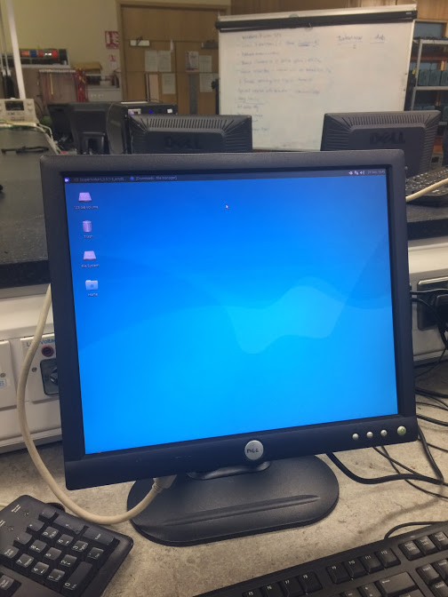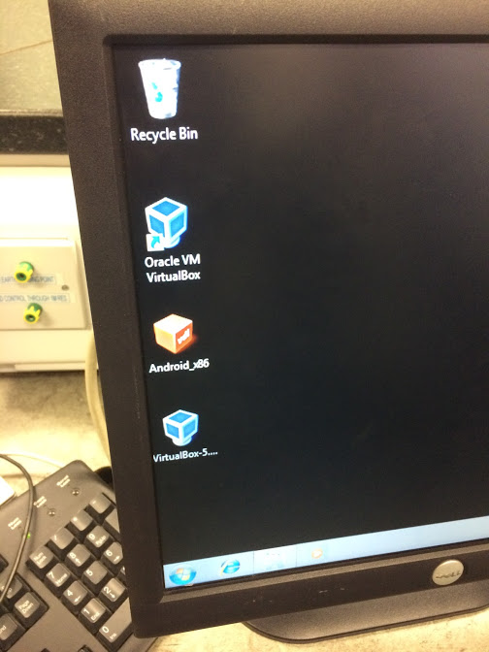

***Ubuntu Linux***

1. Create space on hard drive by shrinking Windows by using disk management tool. Windows can be found in the C drive.
2. Again, plugged in a bootable USB drive with Ubuntu Linux pre-installed on it.
3. Entered the BIOS settings and entered legacy mode.
4. Partitioned the drive for Ubuntu Linux and choose installation type that says to install Ubuntu alongside Windows.
5. Run installer, choose the language and make sure you are connected to the internet. Also, ensure to have enough disk space.
6. Clicked on launch Ubuntu Linux and followed the steps to finish installation. Steps such as keyboard layout and time zone. Also, created a user called dit.
7. It installed and the computer restarted and then on screen instructions followed and process was completed.

***Linux Commands***

1. pwd
2. ls -l
3. cd
4. mkdir
5. chmod
6. man

***Description***

The ***pwd*** command prints the working directory meaning that it tells you the directory you are in at that moment.

The ***ls -l*** command shows a long list of a directory’s contents.

The ***cd*** command lets you change directory, for example if you want to go from the home to the local directory.

The ***mkdir*** command allows you to create a directory.

The ***chmod*** command allows you to change the permissions of a user or group.

The ***man*** command displays the help information for a specified command.

***How They Are used?***

***pwd***, all you have to do is type pwd and this will show you the directory you are currently working in.

Again ***ls -l***, just type it in and it’ll display a long list of directories and files.

The ***cd*** command can be used by typing cd and then two periods after it like this cd.. To go back to a previous directory.

The ***mkdir*** command is used by typing mkdir and then the name of a directory for example, mkdir dir1, this will create a directory called dir1.

The ***chmod*** command can be used to change the abilities of a user or a group for example, chmod go-w myfile means that this will remove the write permission from group (g) other (o). write(w).

The ***man*** command is extremely useful, it is used to show what a certain command does for example, man ls this will show you what the ls command does.

***Appendices A-D***

**Appendix A Bill of Materials**

A ***GAMING COMPUTER*** is a desktop that is often custom-built for increasing performance in modern computer games which may require an increase graphical and processing power. One of the most significant differences between regular and gaming machines is video processing. Gaming computers have video cards with their own dedicated RAM, processor and cooling system, where a typical PC generally uses an [on-board](http://www.computerhope.com/jargon/o/onboard.htm) graphics controller.

***RECON - INTEL X99 - POWERED BY ASUS R.O.G. EDITION***

***Description/Purpose***

The RECON is a world-class gaming system with excellent cooling from the dual fans. It includes eight expansion slots to accommodate multiple graphics cards and many other components. This is the reason I like it so much, it is everything a gamer wants!

It has an Intel-i7 processor which is the fastest one out there and for a gaming PC as high end as this, it is pretty much expected. It also contains a 1TB Hard Drive so you can have a large number of games of your choosing to download.

***Components***

***Motherboard: ASUS Sabretooth X99***

A Motherboard is the spine of your PC, it is the link between all the different components inside your computer. One of the major functions of a motherboard is to act as the “hub” to which other computer devices connect. A board can come in many formations to fit different needs and budgets.

The Motherboard itself is a printed circuit board that allows the CPU, RAM, and all other computer hardware components to communicate with each other.

This gaming computer uses the ASUS Sabretooth X99 motherboard, which costs around 400 euro.

***Processor: Intel Core i7***

A processor is the logic circuitry that responds to and processes the basic [instructions](http://whatis.techtarget.com/definition/instruction) that drive a computer. Most processors today are [multi-core](http://searchdatacenter.techtarget.com/definition/multi-core-processor), which means that the Integrated Circuit contains two or more processors for enhanced performance.

This is exactly what this gaming computer has, a high end multi-core Intel Core i7 processor. This costs around 500 euro.

***Graphics Card: ASUS Stix OC NVIDIA GeForce GTX 1060 [6GB]***

The graphics components are the part of your computer that control and enhance how graphics (pictures, videos, programs, animation, 3D) are displayed on your computer screen.

This computer uses a ASUS Stix OC NVIDIA GeForce GTX 1060 [6GB], which costs around 350 euro.

***Power Supply: EVGA Supernova 850W G2***

A power supply is an internal hardware component which supplies all the computer parts with the power to run them.

This computer uses EVGA Supernova 850W G2 power supply coming in at a cost of 160 euro.

***RAM: 8GB 2666MHz Kingston HyperX Fury DDR4 [2x4GB]***

This is a type of computer memory that can be accessed randomly; that is, any byte of memory can be accessed. RAM is the most common type of memory found in computers.

This computer uses an 8GB 2666MHz Kingston HyperX Fury DDR4 [2x4GB], costing around 60 euro.

***Hard Drive: 1TB 7200RPM [2.5"]***

A hard disk drive (sometimes abbreviated as Hard drive, HD, or HDD) is a memory [hardware](http://www.computerhope.com/jargon/h/hardware.htm) device that permanently stores and retrieves data on a computer. A hard drive consists of one or more platters to which data is written using a magnetic head, all inside of an air-sealed casing to keep it protected from particles that would be harmful to it.

This computer uses a 1TB 7200RPM [2.5"] Hard Drive, which costs around 65 euro.

***Optical Drive: 24x DVD/CD Burner***

An optical disk drive (ODD) uses a laser light to read data from or write data to an optical disc. These include CDs, DVDs, and Blu-ray discs. This allows you to play music or watch movies using pre-recorded discs.

This computer uses a 24x DVD/CD Burner Optical Drive, which costs around 20 euro.

***Cooling: Cooler Master Hyper 212 EVO***

To remove excess heat from a computer system, a cooling system is used.

This computer uses a Cooler Master Hyper 212 EVO, which costs around 35 euro.

***Operating System: Windows 10***

An operating system is the most important software that runs on a computer. It manages the computer's memory and processes, as well as all of its software and hardware. It also allows you to communicate with the computer without knowing how to speak the computer's language.

This computer uses Windows 10 as an OS.

**Appendix B Energy Consumption of a PC**

**Results Of Experiments With The Watt Meter**

|  |  |
| --- | --- |
| Monitor | Watts: 27.9 |
| Stress Test | Watts: 82 |
| Quiescent | Watts: 31 |
| Booting | Watts: 78 |

***My Assumptions***

From this I learnt whilst I was using the Wattmeter is that the “Monitor” alone just on standby uses the least amount of power and from the table the “Stress Test” was the most power consuming because it tests the system’s stability, almost up to a breaking point. Then there is the “Booting” of the PC which uses a good amount of power as well. As the computer is turned on, all the parts of the computer become active and this results in roughly the use 78 WATTS of power. The “Quiescent” was probably the most predictable as this reading was taken when the computer was on but was performing no tasks and no windows were open.

**Calculations for Power Consumption Of A PC In One Year**

Quiescent =31 W*.9 =27.9

Stress Test =82 W*.1 =8.2

Add monitor =27.9 W

Divide 1000/Ans =15.625

Divide .16 by Ans =0.01024 euro per hour

Multiply by 24 to get per day =0.24576 euro per day

Multiply by 365 to get per year =89.7024 euro per year

**Option of a Large Number of PCs in a Server Farm**

***Server Farm***

A server farm is a group of computers acting as servers and housed together in a single location.

***Example***

Assuming Google has 1 million servers each with 1 terabyte of storage (a size Google has already reached or likely will reach in the next year) we can estimate that Google has leap frogged the petabyte and now boasts a total worldwide storage capacity of roughly 1 exabyte.

Google’s data centres use around 260 million watts of power which accounts to 0.01% of global energy. This power is enough to consistently power 200,000 average homes.

***My Assumptions***

From my research of server farms, it is not hard to believe that a company as big as Google uses so much power but at the same time it is astonishing really. I knew Google was used on every computer but to think about the amount of power needed to power their operation as a search engine was kind of hard to believe.

***Cost of Running 1000 PCs In A Server Farm***

89.7024/year of one PC x 1000 = 89,702.40 euro to run a 1000 PCs/year

***Contributing Most to The Bill***

The CPU and Expansion Cards would most likely contribute most to the energy bill.

**Appendix C Electrostatic Charge (ESD)**

***What Is It?***

Electrostatic discharge is the sudden flow of electricity between two objects, it occurs when an object for the static electricity charge nears an object with a lower charge. Static electricity commonly builds up when there’s friction between two objects for example, rubbing a balloon of your hair and touching it can sometimes give you a small shock.

***Method to Prevent ESD Anti-Static Wrist Strap***

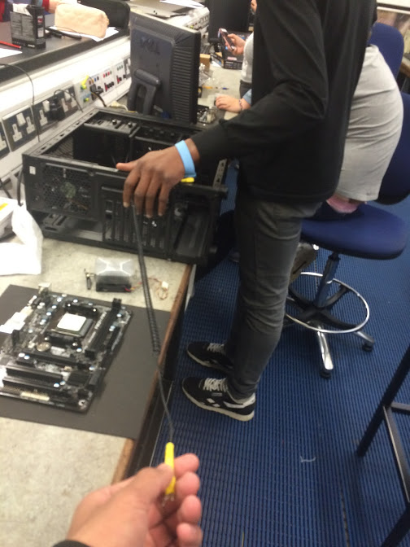

***What It’s Relevance Is to PC Construction?***

Some of the components from a computer are sensitive to ESD and could be damaged, the best method to prevent ESD is using a Grounding/Anti-static wrist strap such as the ones in our lab. These devices are designed to discharge static electricity safely but are only found in labs like the ones in Universities. Also, even if you have this strap on, to always be on the safe side disconnect all cables when working inside of a computer.

When you are working with the PC always make sure to be grounded. The easiest way to do this is to continuously touch an unpainted metal surface on your computer or just make you are standing on a surface that keeps you from getting a shock such as the rubber mats in the lab. Remove any metal jewellery to avoid build-up of extra static electricity.

We need to avoid this static electricity as it can damage a computer’s components. You may not be able to see the damage but it could result in an overload of too much electricity that can permanently damage the components.

**Appendix D Sketch of a PC Layout**

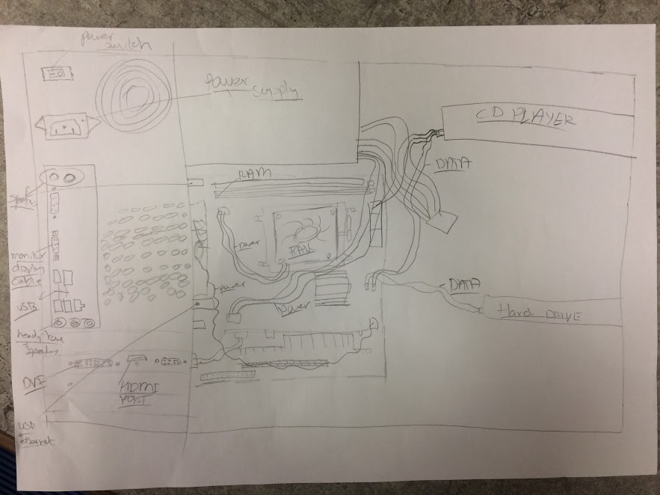

Built PC Layout

